|  |
| --- |
| **NAVRACHANA UNIVERSITY** |
|  |
|  |
| **SCHOOL OF ENGINEERING & TECHNOLOGY** |
|  |
| **BTech-IT** |
|  |
|  |
| **PROJECT**  **RECORD**  **(Review Phase -3)** |
|  |
|  |
| **Final Year B.Tech-IT** |
|  |
| **SEMESTER: 7** |
|  |
|  |
| **COURSE:IN HOUSE PROJECT** |
|  |
| **COURSE CODE:** |
|  |
| **ACADEMIC YEAR: 2022-23 SEMESTER: AUTUMN** |
|  |
| **TEAM ID:23** |
|  |
| **PROJECT NAME: Green Leaf.** |
|  |
| **MEMBER IDs & NAMES: 19125059- Vijay Vaghela, 19125060- Gautam shah.** |
|  |

**PHASE -3 INITIAL IMPLEMENTATION**

**TASK 1: Project Schematic/ Wireframes**

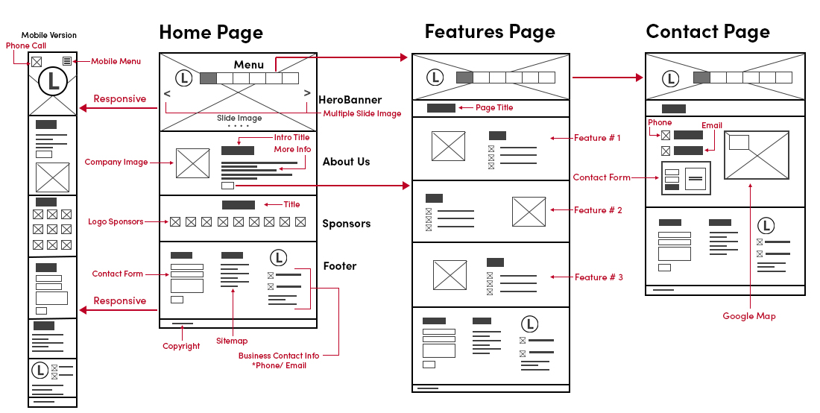

**TASK 2: Circuit Design/Initial UI-UX or Database development:**

Prima facie implementation of your UI/UX module.



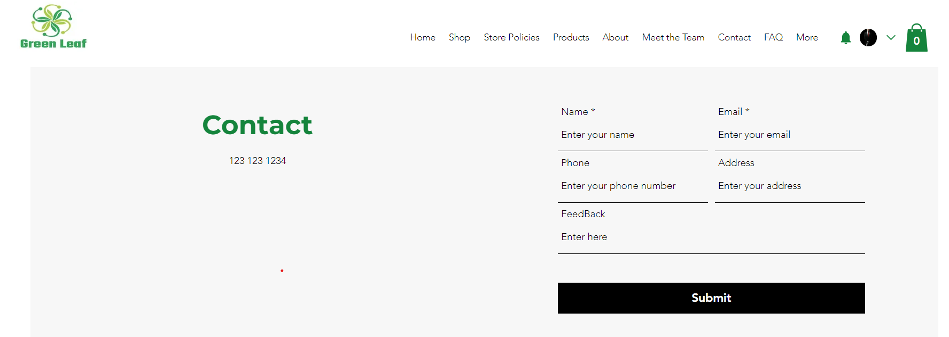

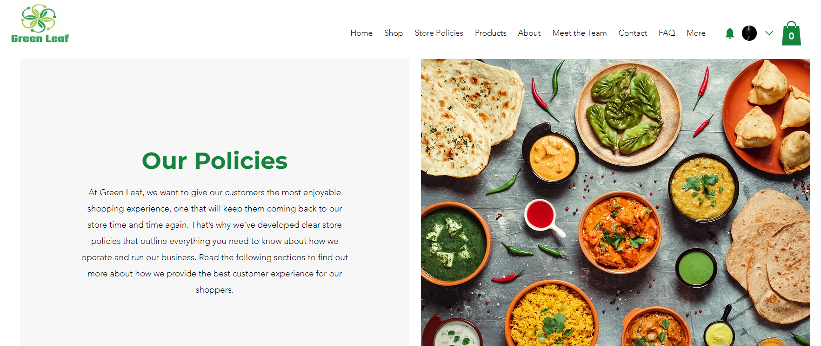

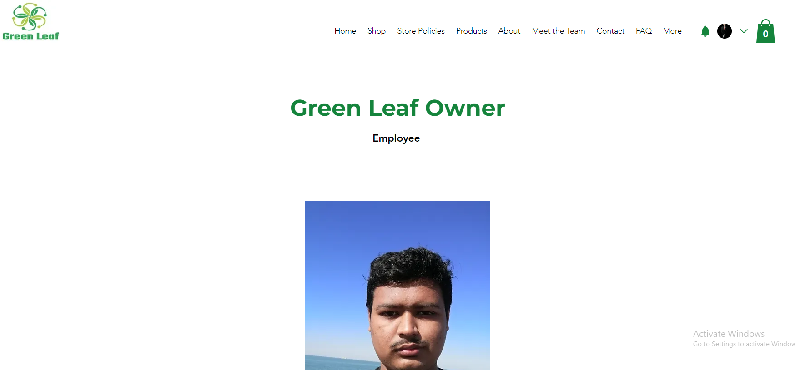

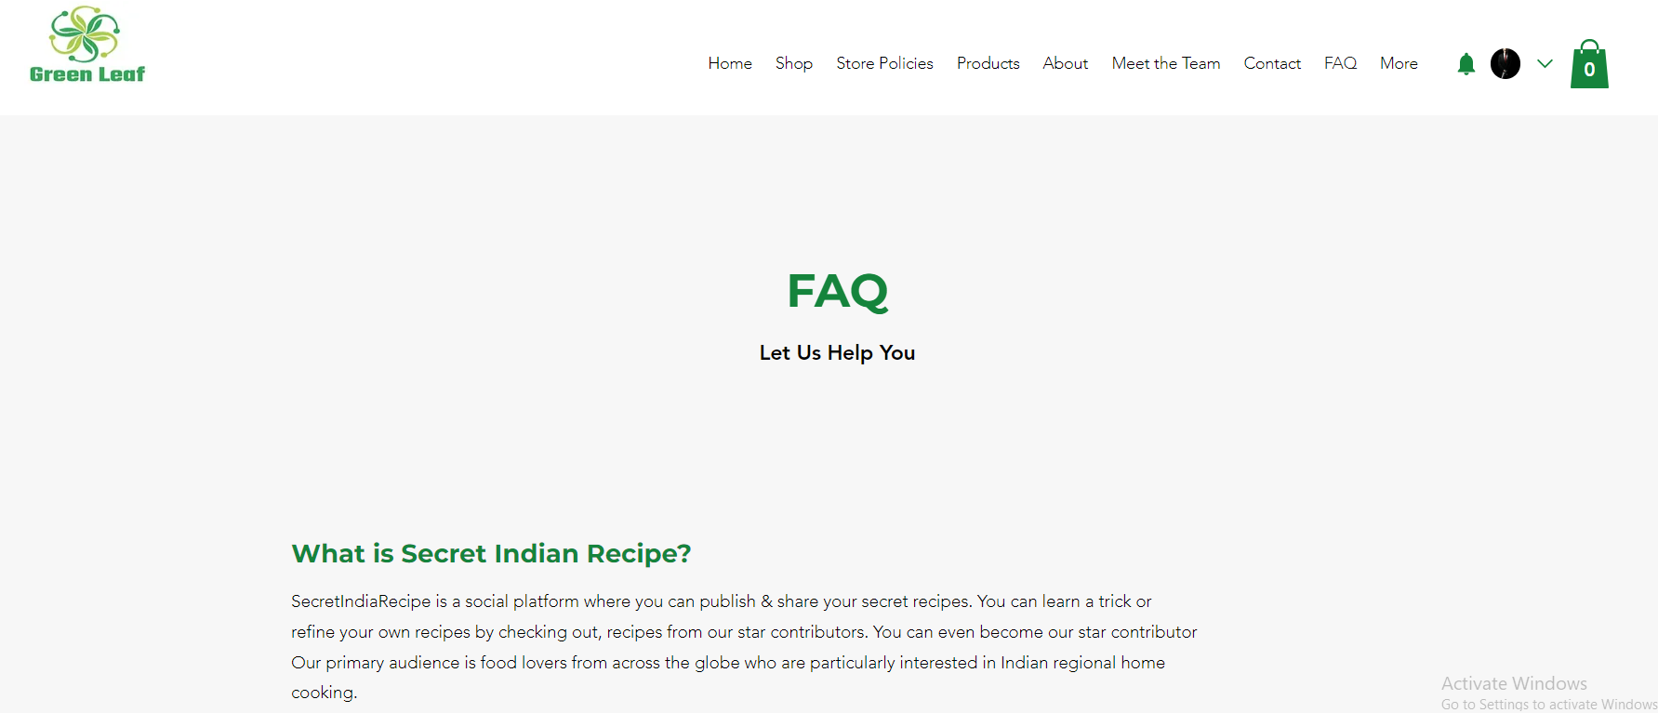

Prima facie implementation of your UI/UX module.

Backend Implementation using this frameworks.

Some popular backend frameworks are **express.** **js, Django, Ruby on Rails**, this can be used as a backend frameworks need an environment conducive to work.

**TASK 3: Specifications**

Specification for E-commerce website list.

**1 Fast, stable & secure web hosting**

In order to publish your eCommerce website, you need a web-hosting service. Web-hosting offers any facilities required to launch, store and maintain websites on the internet. It also takes care of your website’s speed, uptime, and security, which are important for any eCommerce store. We will get into each factor now.

* Security
* Stability
* Speed

**2 Highly-responsive mobile site**

**3 User-friendly web design**

**4 Fast checkout process**

**5 Transparent brand information pages**

For an eCommerce website, homepage, category pages, and product pages are the most important – they boast about your products’ awesomeness.

However, it’s crucial not to ignore other information pages such as:

* About Us
* FAQ
* Terms & Policy
* Size Guide
* Contact Us
* Return Policy

**6 SEO-friendly web pages**

**7 Low shipping fee**

**8 Integration with a digital advertising service**

**9 Blogs**

**FUTURE SCOPE**

**Review History:**

|  |  |  |
| --- | --- | --- |
| **Review No.** | **Suggestions** | **Changes incorporated** |
| 1 | Re-Design UML-model | We have done the necessary changes and started UI/UX design. |
|  |  |  |
|  |  |  |

**Actionable Items:**

* **UI/UX development**
* **Database setup**
* **Setting Up Payment Gateway**

**REFERENCES**

1. <https://www.figma.com>
2. <https://startuptalky.com/ecommerce-website-backend-development/>
3. <https://try.airtable.com/database?utm_source=google&utm_medium=paidsearch&utm_extra5=kwd-16729721&utm_extra2=17337519559&utm_extra10=138052347318&creative=612096827447&utm_extra8=c&cx=row&utm_campaign=demand_nb_database_creator&utm_content=text&utm_term=database%20online&ds_e_utm_extra8=c&gclid=CjwKCAjw7p6aBhBiEiwA83fGuojvpJuNz_6-vTLXk_oUdXsaIW2h7ib8LbPlEw6KifX9XdPRFNdiTRoCinMQAvD_BwE&gclsrc=aw.ds&r=aHR0cHM6Ly93d3cuZ29vZ2xlLmNvbS8%3D>
4. <https://www.google.com/search?q=backend+database+implementation+for+ecommerce+website&rlz=1C1RXQR_enIN1026IN1026&oq=backend+database+implementation&aqs=chrome.1.69i57j33i160.2198j0j7&sourceid=chrome&ie=UTF-8>